**Algebra 2 Honors - Prerequisite Work**

Name:

* If you need help with any of the following topics, you can use Khan Academy or other video tutorial websites, such as You tube, etc. by searching for the topic by name *

**Solving Tips**

*When you solve an equation, you use inverse (“opposite”) operations to help you.

If you are multiplying in the problem, use division to solve (and vice versa).

If you have addition in the problem, use subtraction to solve (and vice versa).

If you have a x² in the problem, use square roots $\sqrt[2]{x²}$ to solve.

If you have $\sqrt[2]{x}$ in the problem, $(\sqrt[2]{x)}²$, square it to solve.

**Inverse Operations**

* Example 1
  + Use inverse operations to solve for the variable: 2x + 1 = 5 {goal: get x by itself}

2x + 1 = 5

2x + 1 – 1 = 5 – 1 {- is the inverse of +}

2x = 4

2x = 4

2 2

x = 2

* Example 2
  + Use inverse operations to solve for the variable. For inequalities, remember to change the direction of the sign if you multiply/divide by a negative number. -6x – 1 ≥ 11

-6x – 1 ≥ 11 {goal: get x by itself}

-6x – 1 + 1 ≥ 11 + 1 {+ is the inverse of -}

-6x ≥ 12 {÷ is the inverse of x}

-6x ≤ 12 {CHANGE direction of sign since negative}

-6 -6

x ≤ -2

* **Practice: Solve for y.**
  1. **7y + 5 = -30**
  2. **-13y – 1 = -40**

**Literal Equations**

* Example 1 {hint: isolate highlighted variable}
  + Solve for y:

Py + Qy = R

y(P + Q) = R {factor out y to further isolate}

y =  {÷ is the inverse of x}

* Example 2: Solve for y:

P = M(2 + Ty)

P = 2M + MTy {distribute M to get rid of parentheses}

P – 2M = MTy {Get y by itself}



* Example 3: Solve for y

x = 

xy = 25B {cross multiply}

y =  {÷ both sides by x}

* **Practice: Solve for y.**
  1. **bx + cy = r**
  2. **Ry – P = xy**

**Solving and Simplifying**

* Example 1: Solve for x. {Hint: If the same variable is on both sides of the =, move the variables to 1 side and the #’s to the other side of the = by using inverse operations.
  + -5x + 6 = 8x – 20 {move the x’s to the side with the largest x value}

-5x + 5x + 6 = 8x + 5x – 20 {+ is the inverse of -}

6 = 13x – 20 {combine like terms on the same side of the =}

6 + 20 = 13x – 20 + 20 {move the #’s to the side without the variable}

26 = 13x

26 = 13x {÷ is the inverse of x}

13 13

x = 2

* **Practice: Solve for x**
  1. **3x + 4 = 7x – 11**
* Example 2: Solve for x. {When you have a term on the outside of ( ), you must multiply it by every term on the inside of the parentheses. Make sure you are careful with the signs of each term. Remember (-2)(-2) = 4 and (-2)(2) = -4.}
  + -4(3x – 8) = 3(6x + 10) {multiply -4 by each term inside the 1st ( ) and 3 by -12x + 32 = 18x + 30 every term inside the 2nd ( ) }

-12x + 12x + 32 = 18x + 12x + 30 {move the x’s to the side with the largest x value}

32 = 30x + 30 {combine like terms on the same side of the =}

32 – 30 = 30x + 30 – 30 {move the #’s to the side without the variable}

2 = 30x

2 = 30x {÷ is the inverse of x}

30 30

x = 1

15

* **Practice: solve for x**

1. **2(5x + 3) = -4(2x – 7)**
2. **-6x2(-4x – x) = -(5x3 – 7x2)**

* Example 3: Simplify {When there are no = signs, get in standard form (highest exponent to smallest) and combine like terms.}
  + 7x2 – 4x – 3x2 + 2 + 8x

7x2 – 3x2 + 8x– 4x + 2 {Like terms are now next to each other; same variable, same

4x2 + 4x + 2 exponent} s

* **Practice: Simplify.**

1. **-5x2 + 9x + 3x2 – 12x**
2. **-x -2x2 + x3 – x2 –x – x3**
3. **-2(-5x + 3) + 4(3x – 2)**

**Absolute Value**

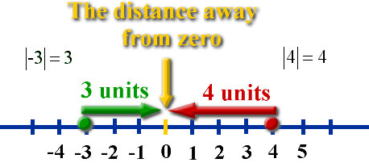

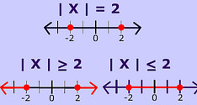

* Example 1: | x + 2 | = 10 {by definition: set expression inside bars = 10 and the opposite
  + |x + 2| = 10 of 10.}

x + 2 = 10 or x + 2 = -10

x = 8 or x = -12

* Example 2: Solve for x.
  + 2| x + 2 | = 10

| x + 2 | = 5 {Get abs. value alone. ÷ both sides by 2 before use definition}

x + 2 = 5 or x + 2 = -5 {by definition: set expression inside bars = 5 and the opposite

x = 3 or x = -7 of 5.}

* Example 3: Absolute value inequality.
  + | x - 2 | > 2

x – 2 > 2 or x – 2 < -2 {by definition}

x > 4 or x < 0

* Example 4: Absolute value inequality.
  + |x + 2| < 8

-8 < x + 2 < 8 {by def; Solid line of graph is in “middle →x = middle of equation}

-8 - 2 < x + 2 – 2 < 8 – 2

-10 < x < 6

* **Practice**

1. **|x – 1| ≥ 6**
2. **3|x + 7| = 15**

**Proportions**

* Example 1: Solve for x. { When you have a proportion (1 fraction = 1 fraction), cross multiply.}
  + 6 = 2

15 x

6x = 2(15)

6x = 30

6x = 30

6 6

x = 5

* **Practice: solve for x.**

1. **7 = 5**

**x 2**

1. $\frac{x+7}{x+3}$**= $\frac{x}{5}$**

**Radicals and Roots**

* Example 1:
  + x2 = 4, then x = 2 or x = -2
* Example 2:
  + If x2 = 4 , then x = +/- $\frac{\sqrt{4}}{\sqrt{3}}$ Now you will need to rationalize the denominator {make it a

3 perfect square}

x = +/- $\frac{\sqrt{4}}{\sqrt{3}}$ ● $\frac{\sqrt{3}}{\sqrt{3}}$ = +/- $\frac{2\sqrt{3}}{3}$ {multiply top and bottom by another radical →perfect square.}

* Example 3:
  + If = 8, then ( )2= 82

x = 64

* Example 4:
  + x2 = 

x2 =  {perfect square factor times other factor}

x= 2

* Example 5:
  +  +  =  + 

2 + 4= 6

* **Practice: Simplify each radical expression**

$\sqrt{18}$

2. $\sqrt{50}$**+ $\sqrt{32}$**
3. $\sqrt{7}$**● $\sqrt{6}$**

$\frac{64}{6\sqrt{80}}$

$\frac{3}{4\sqrt{2}}$

* **Practice: solve for x {get x by itself and then decide do you need to *square* it or *square root* both sides?}**

1. **4x2 + 3 = 17**
2. **8= 64**
3. $\sqrt{x}$**- 1 = 6**

**Factoring**

* Example 1: Factor out the Greatest Common Factor (GCF)

THIS IS ALWAYS THE 1ST STEP IN ANY FACTORING PROBLEM

* + 5x + 35

5(x + 7)

* Example 2: difference of squares {double bubble with different signs and square roots in them}
  + x2 – 81

(x)2 – (9)2

(x + 9)(x – 9)

* + 4x2 – 16

4(x2 – 4) {gcf: look for # and variable in common}

4(x – 2)(x + 2) {2 terms: look for difference of squares}

* 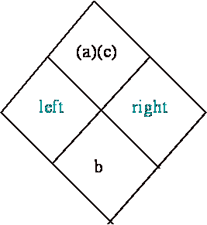Example 3: Trinomials with a = 1
  + ax2 + bx + c

x2 + 13x + 36

↑ what 2 factors of 36 multiply to give you 36

↑ and add to give you 13

4 + 9 = 13 {check}

(4) ● (9) = 36 {check}

(x + 4)(x + 9)

* Example 4: Factor
  + -3x3 – 15x2 + 18x {take out gcf: look for # and variable in common}

-3x(x2 + 5x – 6) {continue to factor expression in parentheses}

-3x(x – 1)(x + 6) {list factors of 6 and decide which 2 factors add to +5}

* **Practice: factor each expression.**

1. **18x + 12**
2. **x² – 14x + 24**
3. **x2 – 25**
4. **x² – 7x – 18**
5. **x2 + 10x + 21**

* **Practice: *Solve* by factoring. {Hint: After factoring, set each parentheses = 0 and solve; You will get 2 answers.}**

1. **x2 + 5x – 14 = 0**

**Quadratic Formula**

* The quadratic formula can help you solve any quadratic equation, even those that aren’t factorable. To use the formula, the equation must be in standard form, ax2 + bx + c = 0

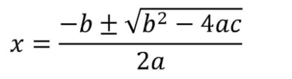

* Example 1: x2 + 6x + 5 = 0
* a = 1, b = 6, c = 5

$x=\frac{-6±\sqrt{6^{2}-4\left(1\right)(5)}}{2(1)}$

$$x=\frac{-6±\sqrt{36-20}}{2}$$

$$x=\frac{-6±\sqrt{16}}{2}$$

$$x=\frac{-6±4}{2}$$

$x=\frac{-6+4}{2}$ = -1

$x=\frac{-6-4}{2}$ = -5 Therefore, x = -1 or -5

* **Practice: solve using the quadratic formula {hint: put in standard form FIRST}**

1. **3x2 = 2x + 1**

**Multiplying Expressions**

* There are 2 methods to multiplying 2 binomials {2 terms} together.

1. FOIL→ (binomial)(binomial)
2. Distribution → only option if you have 3 or more terms in any parentheses.

* Example 1: (3x + 2)(x - 5)

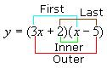

(3x1)(x1) + (3x)(-5) + (2)(x) + (2)(-5)

F + O + I + L

3x2 – 15x + 2x – 10

3x2 – 13x – 10

* Example 2: (2x – 1)(x3 + 7x + 4)
  + 2(x3 + 7x + 4) + (-1)(x3 + 7x + 4) =

2x3 + 14x2 + 8 + -x3 -7x – 4 =

x3 + 14x2 - 7x – 4

**Least Common Denominator (LCD)**

* You must have a common denominator when you + or – fractions
* Example 1: 
  + {Prime factor by listing factors or using a factor tree}

4 = 22

10 = 21•5

14 = 21•7

* LCD =

1. Every prime factor raised to the highest power that occurs amongst all terms/factors ; 22 or 4, 5, 7
2. Multiply them all together; 4•5•7 = 140

* = {change each fraction to an equivalent fraction with denom = 140 }

={multiplying by 1 when multiply top & bottom by same #}

= {combine numerators and put over single denominator}

 {simplify}

= {  }



* Example 2: Determine the LCD.
  +  {*Notice* similarities & differences between this problem and previous}

4 = 22

10x = 21•5•x

14x2 = 21•7•x2

* + LCD =

1. every prime factor raised to the highest power that occurs amongst all terms/factors ; 22 or 4, 5, 7,x2
2. multiply them all together; 4•5•7•x2 = 140x2

* Example 3: Find the LCD.



LCD = x(x+1)(x+2) {leave in factored form}

* Example 4: Find the LCD.

 {prime factor 6 = 2•3 and 4 = 22}

LCD = 12x2(x-1) {leave in factored form}

* Example 5: Find the LCD.

 {Factor so you know common and uncommon terms}

 {1st denom = difference of squares; 2nd = diamond

factoring with the x}

LCD = (x+3)(x+1)(x – 3) {leave in factored form}

* Example 6: Find the LCD.

 {Factor so you know common and uncommon terms}

 {1st denom = difference of squares}

LCD = (4x+3)(4x – 3) {leave in factored form}

* **Practice: Determine the LCD.**

1. $\frac{1}{x{\left(x+4\right)}^{2}}$**+ $\frac{1}{x^{2}+ 11x+28}$**
2. $\frac{2}{6(4x^{2}- 9)}$**+ $\frac{5}{{(2x+3)}^{2}}$**

**Exponent Rules**

* Example 1:
  + x2 ● x5 = x2 + 5 = x7
* Example 2:
  + x5 = x5- 2 = x3

x2

* Example 3:
  + (2x5)2 = 22 x5●2  = 4x10
* Example 4:
  + (5x)-2  = = =
* **Practice:**

1. **15x12**

**5x7**

1. **(3x4 )2**
2. **(3x4y)(5x3y5 )**
3. **2x-3**
4. **(2x)-3**

**Ordered Pairs**

* 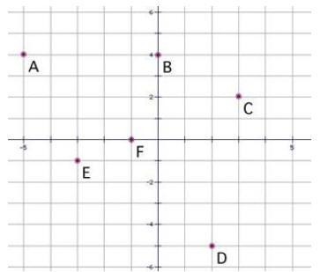Example 1: Ordered Pairs → order matters
  + (x, y)

↑ count left if - ; count right if + {x- axis goes ↔}

↑ count down if - ; count up if + {y-axis goes ↕ }

* Example 2: Determine the Ordered Pairs of the graph to the right
  + A(-5, 4) {left means negative, up means positive}
  + B(0, 4) {no movement means 0, up means positive}
  + [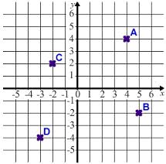](http://www.google.com/imgres?q=coordinates+of+the+graph&um=1&safe=active&sa=N&rls=com.microsoft:en-us:IE-SearchBox&hl=en&biw=1008&bih=722&tbm=isch&tbnid=ypbJ4uY7UmC2LM:&imgrefurl=http://www.cimt.plymouth.ac.uk/projects/mepres/book8/bk8i14/bk8_14i1.htm&docid=vkDrcd0-JdWs2M&imgurl=http://www.cimt.plymouth.ac.uk/projects/mepres/book8/bk8i14/s1eg1graph.gif&w=269&h=266&ei=pNecUeLNO4jq0AHQmIGYAQ&zoom=1&iact=hc&vpx=417&vpy=80&dur=3510&hovh=212&hovw=215&tx=124&ty=113&page=4&tbnh=141&tbnw=143&start=85&ndsp=31&ved=1t:429,r:94,s:0,i:371)C (3, 2) {right means positive, up means positive}
  + D (2, -5) {right means positive, down means negative}
  + E (-3, -1) {left means negative, down means negative}
  + F (-1, 0) {left means negative, no movement means 0}
* **Practice: State the Ordered Pairs of the graph to the right**

1. **A ( , )**
2. **B ( , )**
3. **C ( , )**
4. **D ( , )**

**Slope Intercept Form of a Line**

* 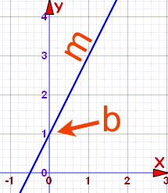Textbook Help
  + Algebra 1: textbook p. 351
* Slope Intercept Form: y = mx + b

slope y intercept {where the line crosses the y- axis}

* You can count the slope from 2 points on the line = rise

Run

* Or you can also use the slope formula m = y2 – y1

x2 – x1

* There are 3 types of special lines
  + Vertical (VUX),

Vertical lines

Undefined slope

X = # is equation

* + Horizontal (HOY),

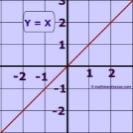Horizontal lines

O slope

Y = # is equation

* + Diagonal through the origin {y = x and y = -x}
* **Practice: Write the equation for the given lines.**

1. **42.**

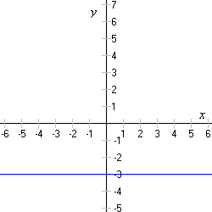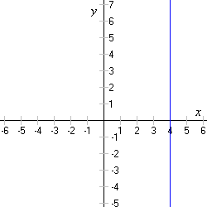

**System of Equations**

* The solution to a system of equations = the point both graphs have in common; the intersection point.
* Three ways to solve a system of 2 equations: 1) substitute, 2) eliminate, 3) graph
* Goal of elimination: To get the coefficients the same but different signs of the same variable.
  + Simplistic Idea:
    - 5x – 5x = 0, 2x – 2x = 0 {In each of these examples, “x” would be “eliminated.”}
  + Steps:
    - Step 1: Can you add the equations and eliminate a variable?
    - Step 2: Can you multiply each term of 1 equation by a # and then add and eliminate a variable?
* Example 1: Elimination
  + x + 3y = 6 {multiply each term by -2 so when we + the columns, x’s are eliminated}

2x + y = 37

-2x – 6y = -12 {add each column, you will notice the x’s will be eliminated}

2x + y = 37

-5y = 25

y = -5 {substitute y = - 5 into either of the original equations given, to find x}

x + 3y = 6 {original equation #1}

x + 3(-5) = 6

x – 15 = 6

x = 21

Answer (x, y) = (21, -5) {It is an ordered pair because this point is the intersection of the 2 lines}

* Goal of substitution: Solve for 1 variable in the easiest equation. Replace it’s “answer” in the other equation for the variable you solved for.
  + Simplistic Idea:
    - 4x = 8 {Solve for x} → x = 2

x + y = 7 {Replace 2 for x in this equation}

2 + y = 7 → x = 5

Answer (2, 5) This is the point of intersection of the 2 lines.

* Example 2: Substitution {This is the same problem as above, so you will get same answer}
  + x + 3y = 6 {solve for 1 variable; look for variable without coefficient}

2x + y = 37 {other equation}

x = -3y + 6 {take this new way to write x and replace it for x in the other equation}

2x + y = 37

2(-3y + 6) + y = 37

-6y + 12 + 1y = 37

-5y + 12 = 37

-5y = 37 – 12

-5y = 25

y = -5

( , -5) You need an ordered pair answer.

***Substitute*** y = -5 in either original equation to find x.

x + 3y = 6

x +3(-5) = 6

x – 15 = 6

x = 15 + 6 →x = 21

The point of intersection on the graph is (21, -5)

* Goal of graphing: Graph each line on the same graph & name (x, y) where the lines intersect.
* **Practice: Solve the system using any method.**

1. **3x + 2y = -4**

**x – 5y = 27**

**Graphs**

* Graphs are extremely important in higher level math. You will need to be able to:

1. Quickly sketch a graph of any equation and be able to
2. State key features.

* As you proceed in Algebra2 Honors, you will accumulate more graphs. You will need to easily recall & provide a quick sketch of them.
* Example 1: Linear Graphs
  + x1  The exponent tells us this is a linear graph.

{x intercept is the ordered pair where the graph crosses the x-axis}

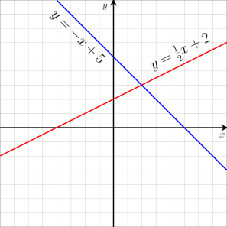

* **Practice:**

1. **Identify x intercept of red line ( , 0); y intercept of red line (0, )**
2. **Identify slope of red line: m =**
3. **Identify x intercept of blue line ( , 0); y intercept of blue line (0, )**
4. **Identify slope of blue line: m =**

* Example 2: Quadratic Graphs
  + x2  The exponent tells us this is a quadratic graph.

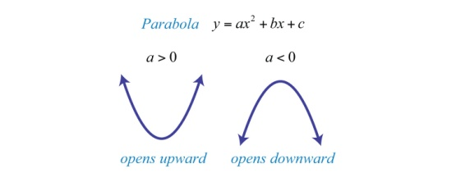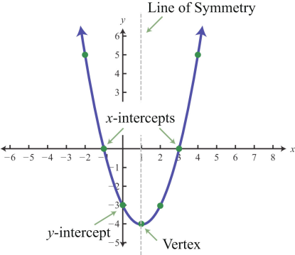

* **Practice (look at the graph above on the right)**

1. **x intercepts ( , 0) y intercept (0, )**
2. **Line (or Axis) of Symmetry: x = ___**
3. **Vertex ( , )**

* Example 3: Absolute Value Graphs
  + - │x│ The bars tell us this is an absolute value graph.

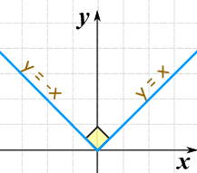

* Example 4: Domain & Range
  + Domain and range are necessary information to provide with each graph you complete.

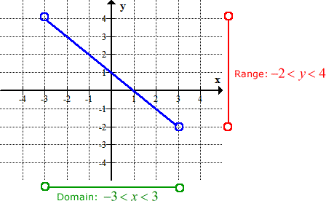 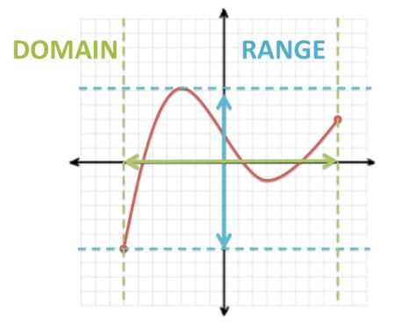

Domain: [-7, 8]; Range: [-6,5]

* **Practice:**

1. **Identify the domain:**
2. **Identify the range:**

